Steps for installing and/or updating the Draw My CA plugin

- Navigate to https://redistrictinggroup.org/geodata/, scroll to the bottom of the page, and download the ‘swdbqgis.zip’ file at the bottom.

- After the zip file is downloaded, navigate to the file in your Downloads folder and click copy. You will then paste the file directly into the following file path:
C:\Users\[Your account here]\QGISSWDB\profiles\default\python\plugins

Note: If your QGIS has a different file path or you do not know your QGIS file path, you can find the plugin’s folder location by opening QGIS, navigating to ‘Settings’ > ‘User Profiles’ > ‘Open Active Profile Folder’. See below:

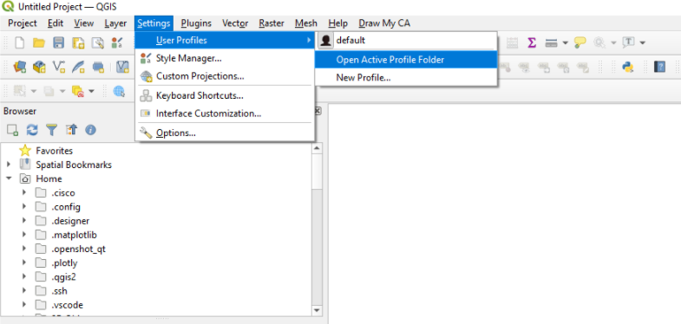

- Before proceeding to step 4, make sure to first close QGIS if you have it open, as leaving it open will inhibit the next steps of the plugin installation.

- Open the ‘python’ folder, then the ‘plugins’ folder within it (see below):

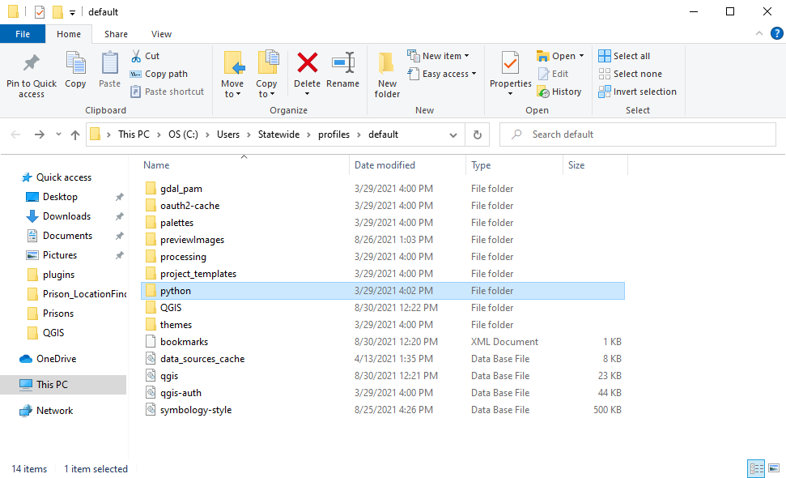

- Following the correct file path should lead to the destination seen below. Here you will paste the downloaded zip file you previously copied from your downloads folder.

Note: if you have a previous version of the plugin installed, you will need to delete its folder before pasting the new zip file.
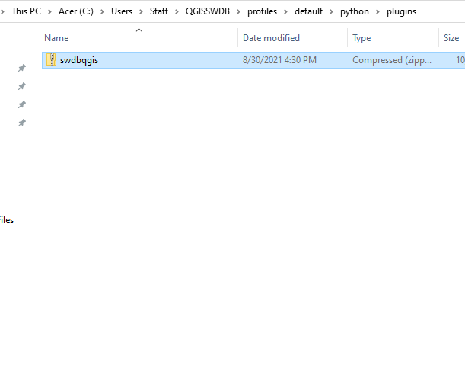

- Right click the zip file and click Extract.

- Once the zip file is finished extracting, open the file. This will lead to the following folder destination:

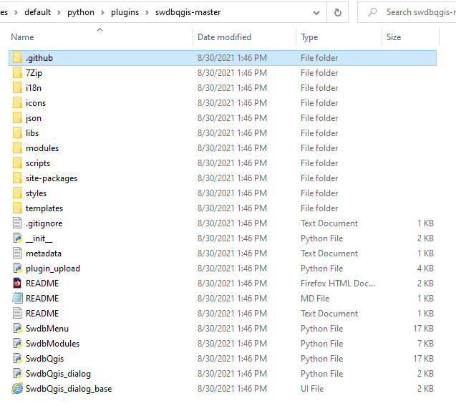

- Delete the ‘github’ folder highlighted in the above image.

- After you have deleted the folder, make sure the folder name is ‘swdbqgis’, then delete the ‘swdbqgis.zip’ folder. This concludes the plugin installation/update process.

The resulting plugin file should look like this:

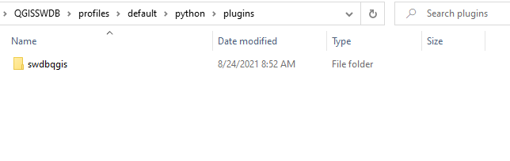

To confirm the installation was successful, open QGIS as administrator (right click > Run as administrator) and look at the Menu Bar at the top. The Draw My CA plugin should appear on the right if the installation was successful. See below:

